LAB ASSIGNMENT 1 & 2



NAME : MUHAMMAD HAZEEQ HAIKAL BIN ROSLAN

MATRIX.NO : 2022676488

GROUP : RCDCS1102B

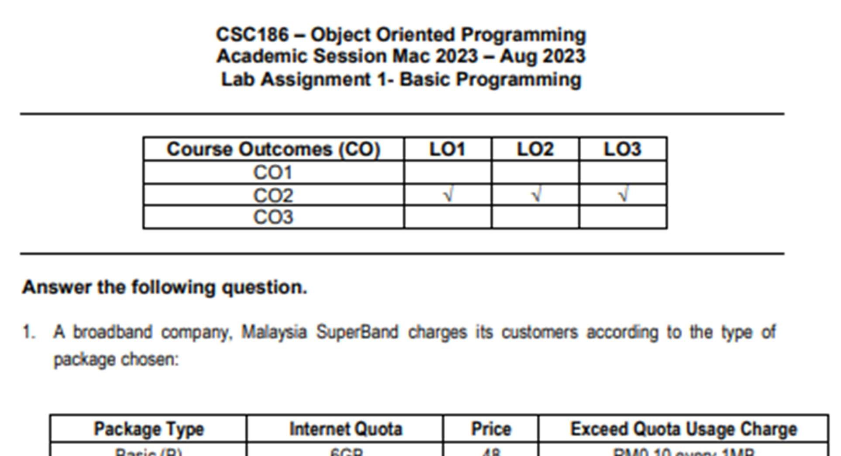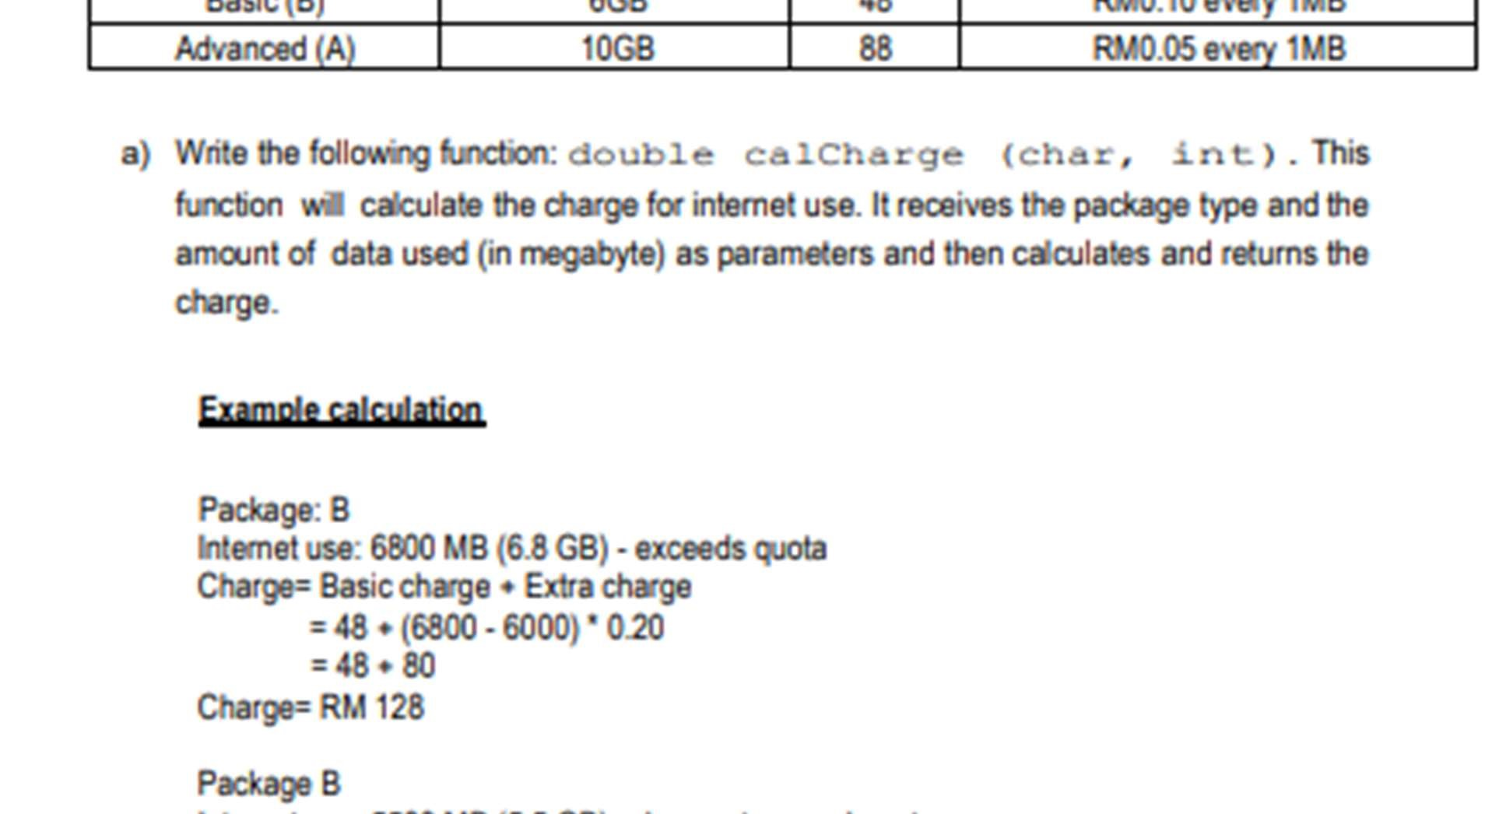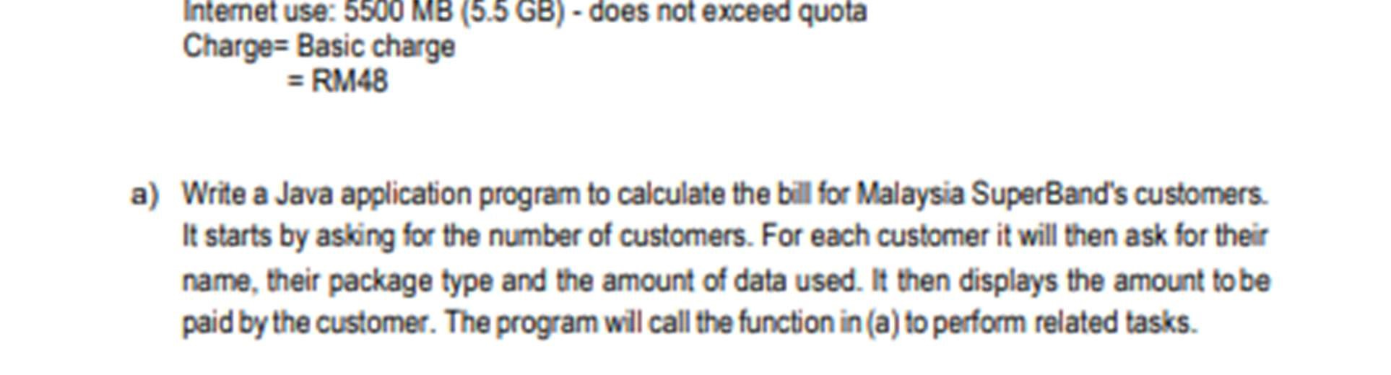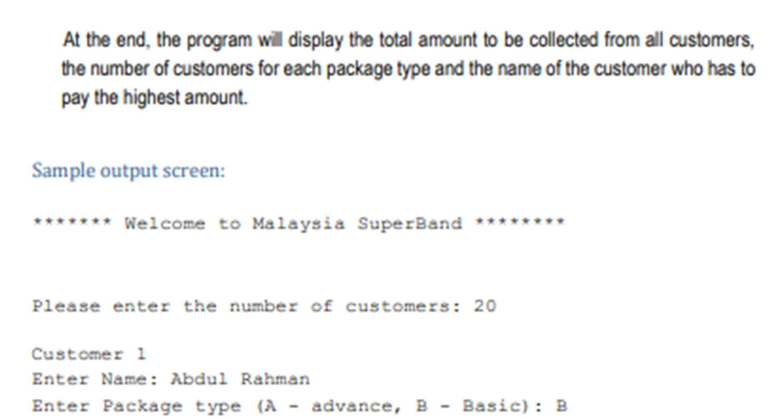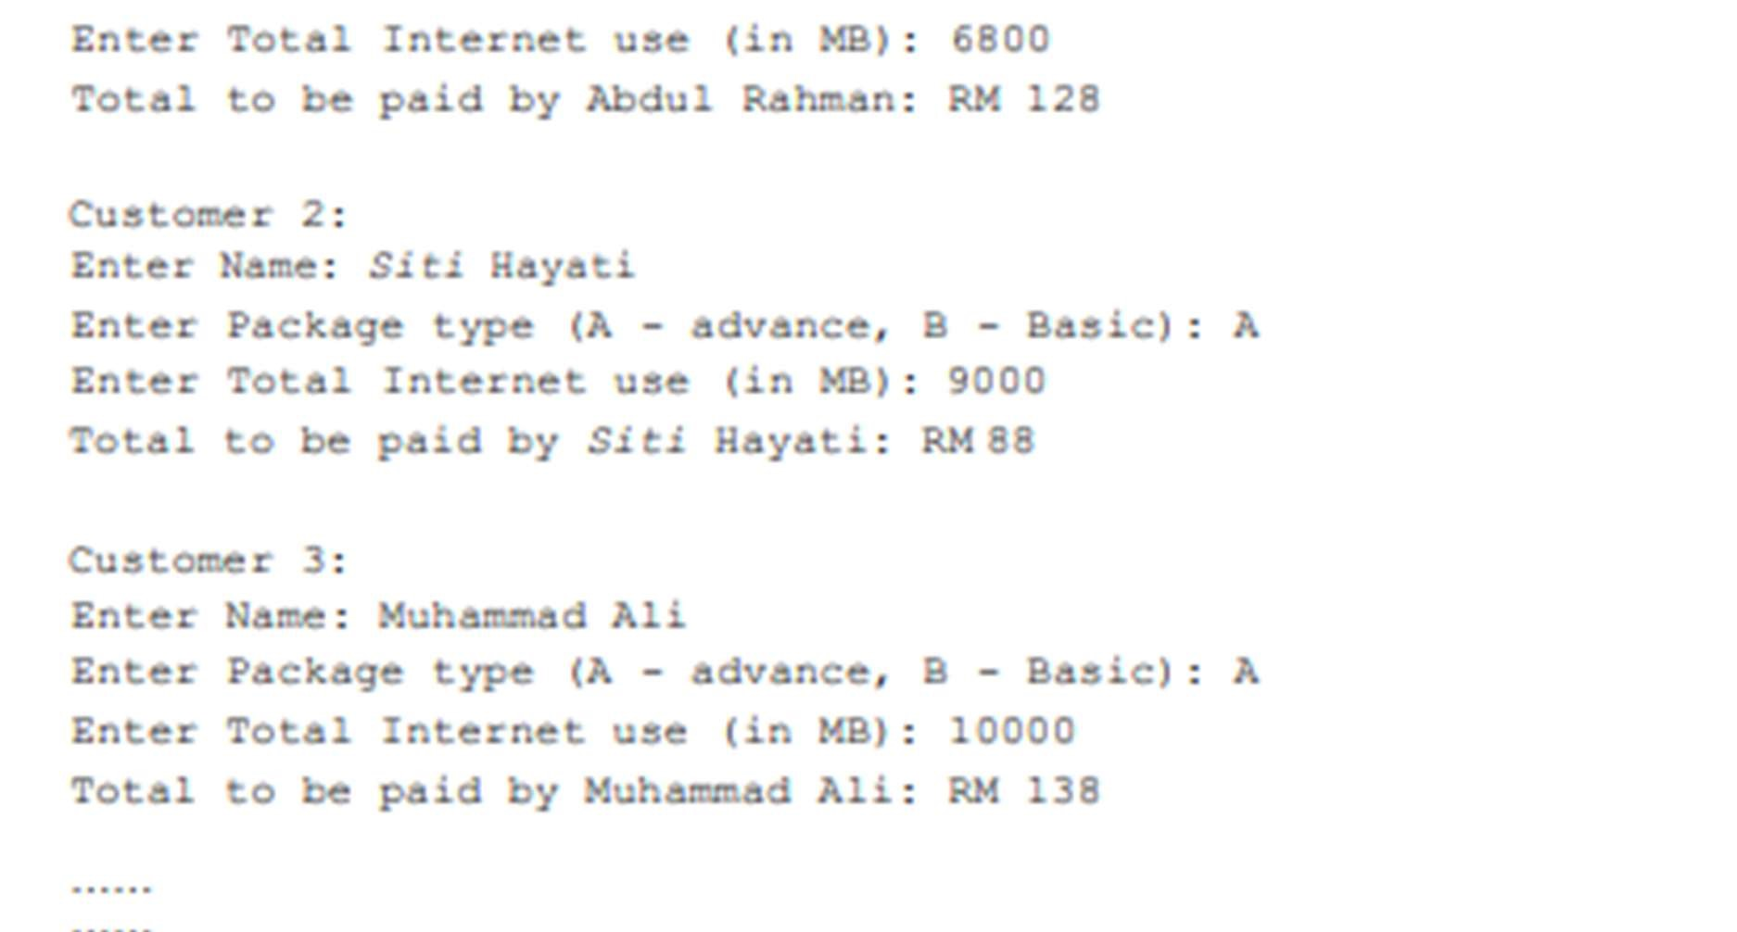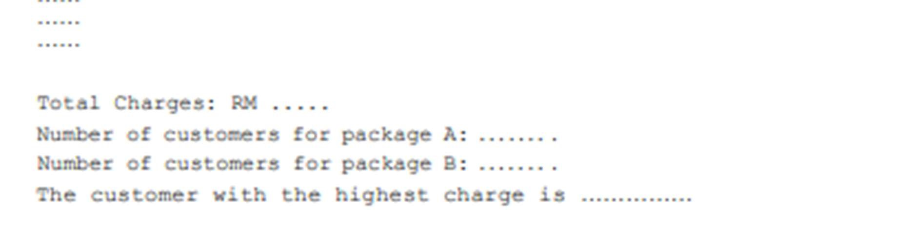

# SAMPLE INPUT

# 

# SAMPLE OUTPUT

# LAB ASSIGNMENT 2

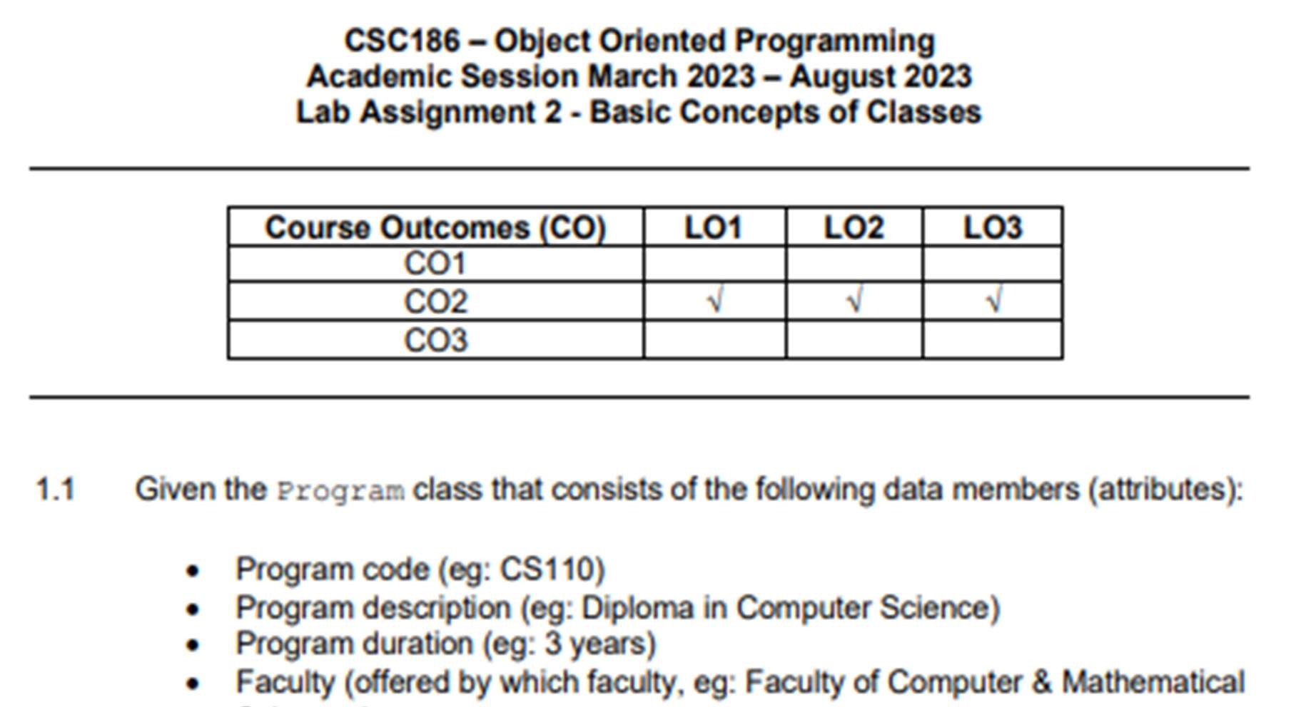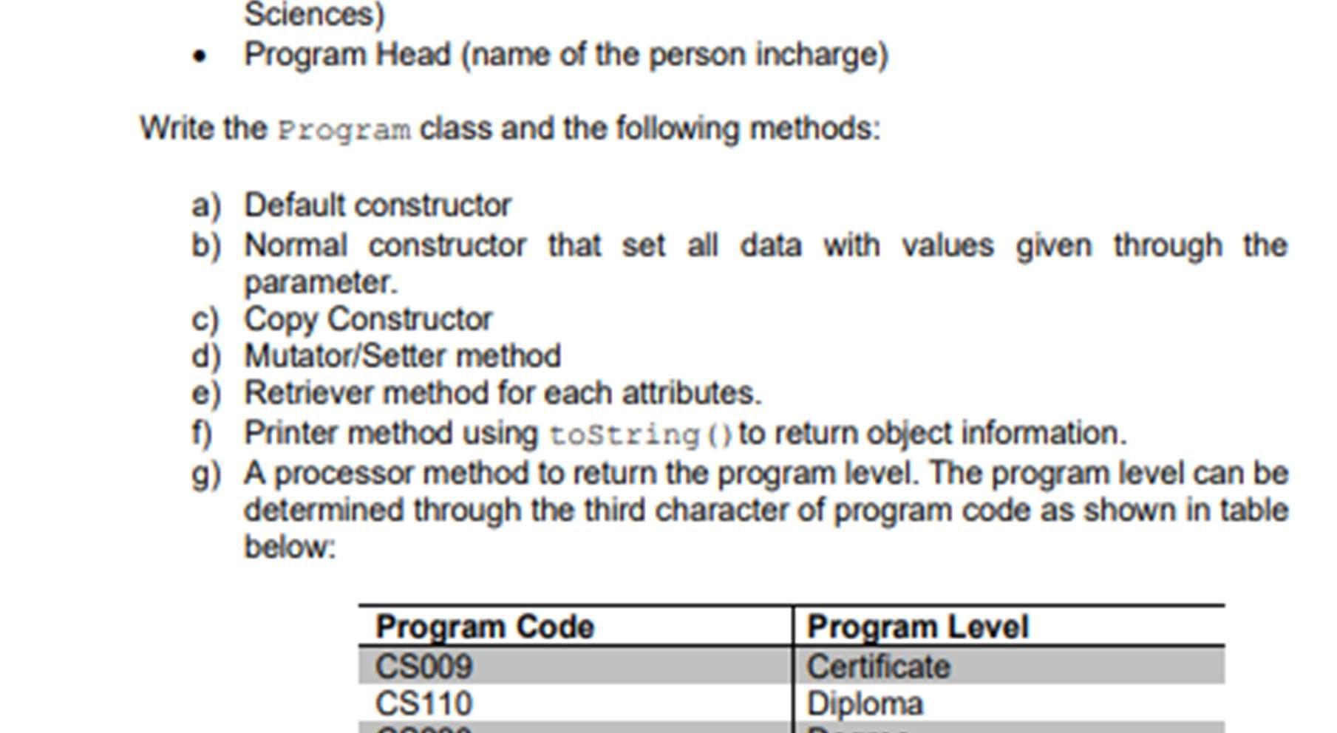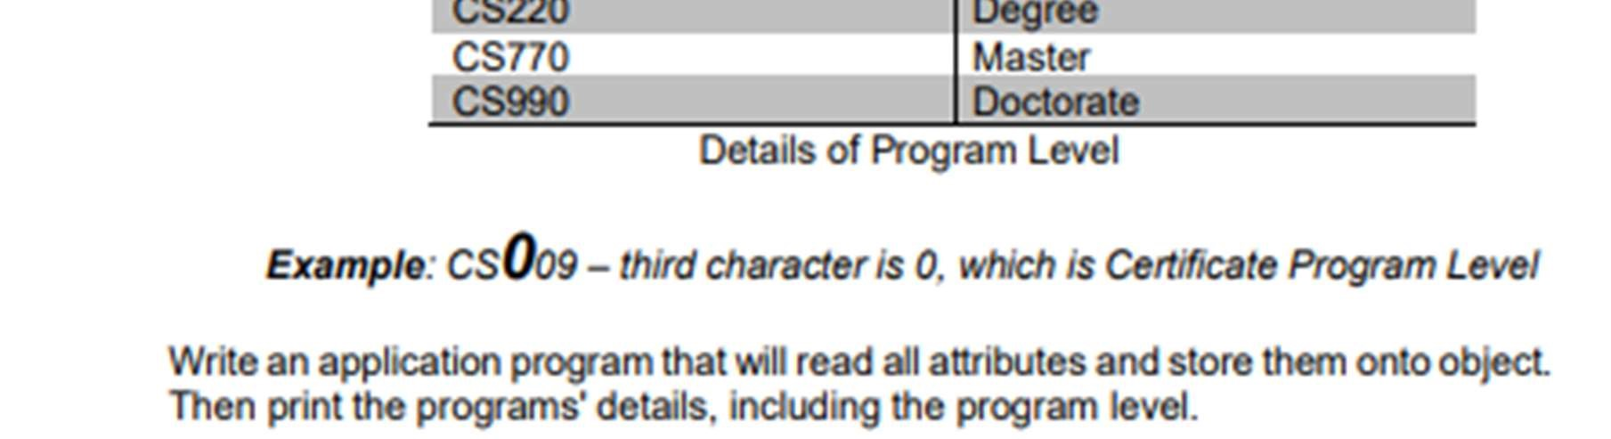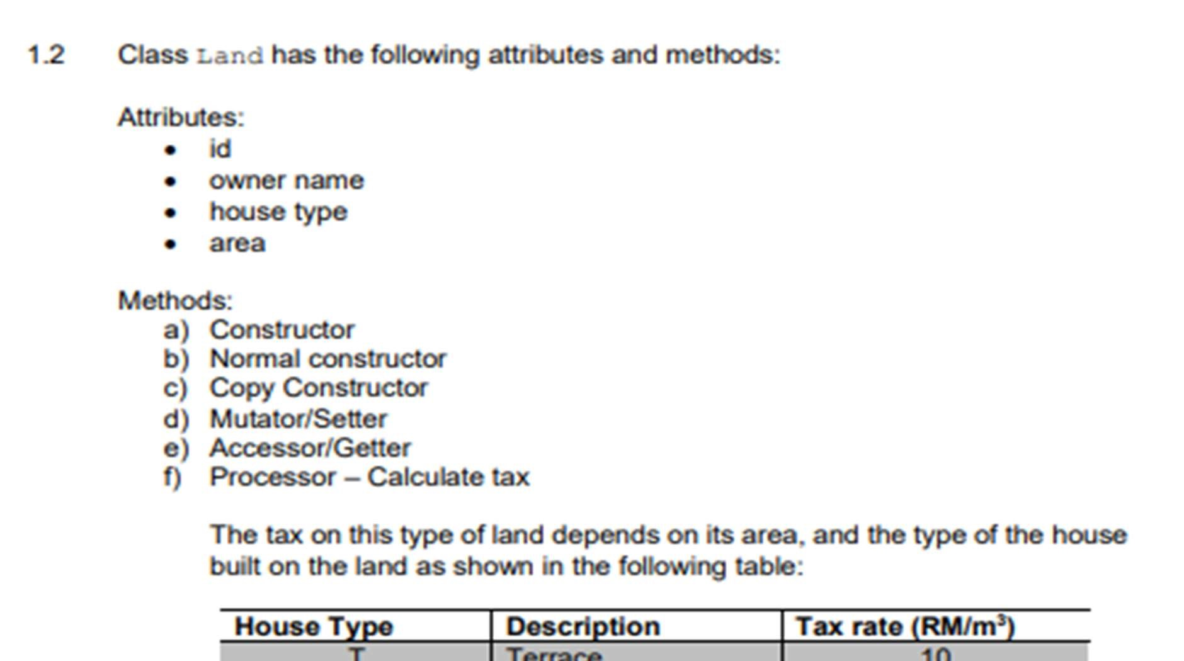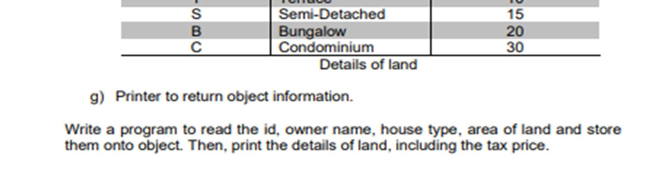

# SOURCE CODE (PROGRAM APP / MAIN METHOD) - <https://pastecode.io/s/h9bhgwbq>

SAMPLE INPUT

SAMPLE OUTPUT

# SAMPLE INPUT

# SAMPLE OUTPUT

